Spring Core and Maven
Exercise 1: Configuring a Basic Spring Application
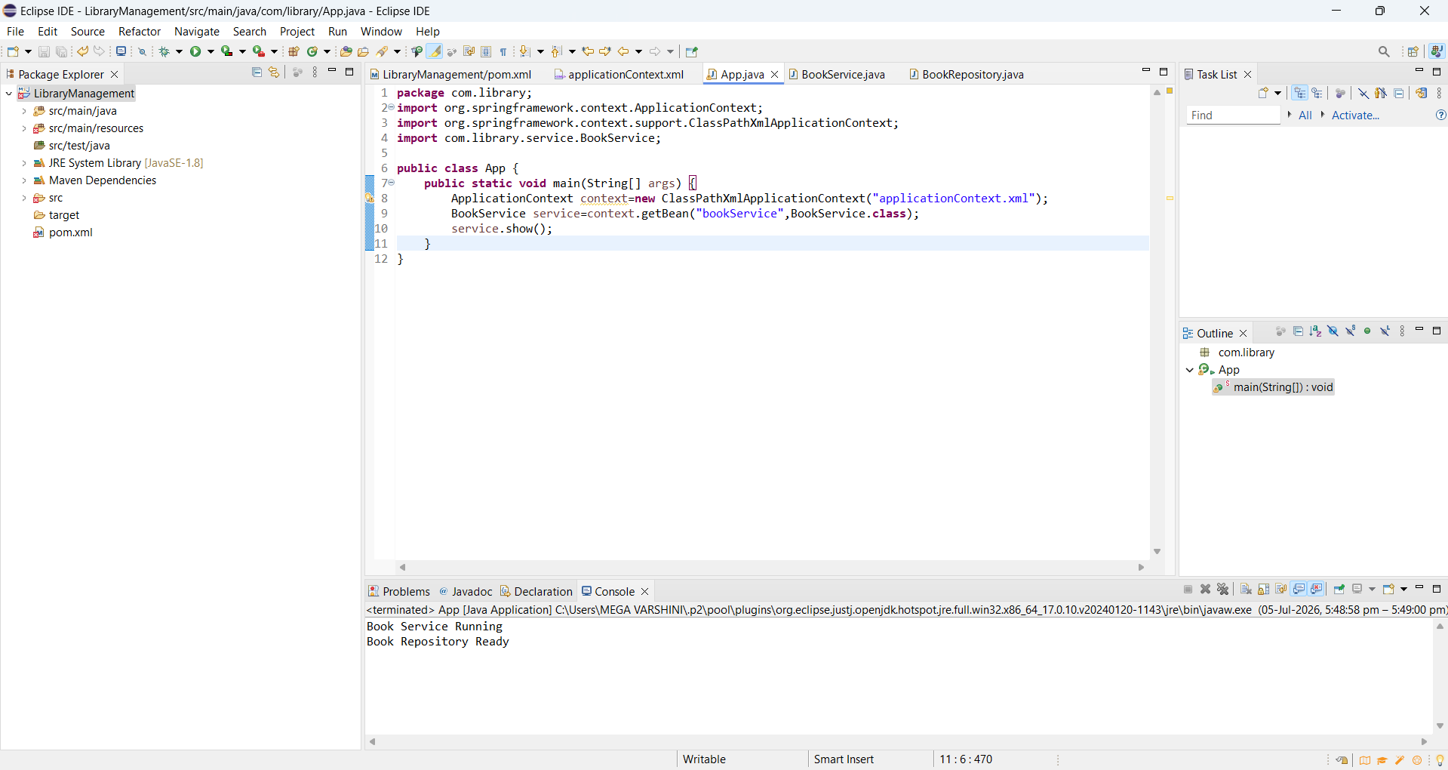
Exercise 2: Implementing Dependency Injection
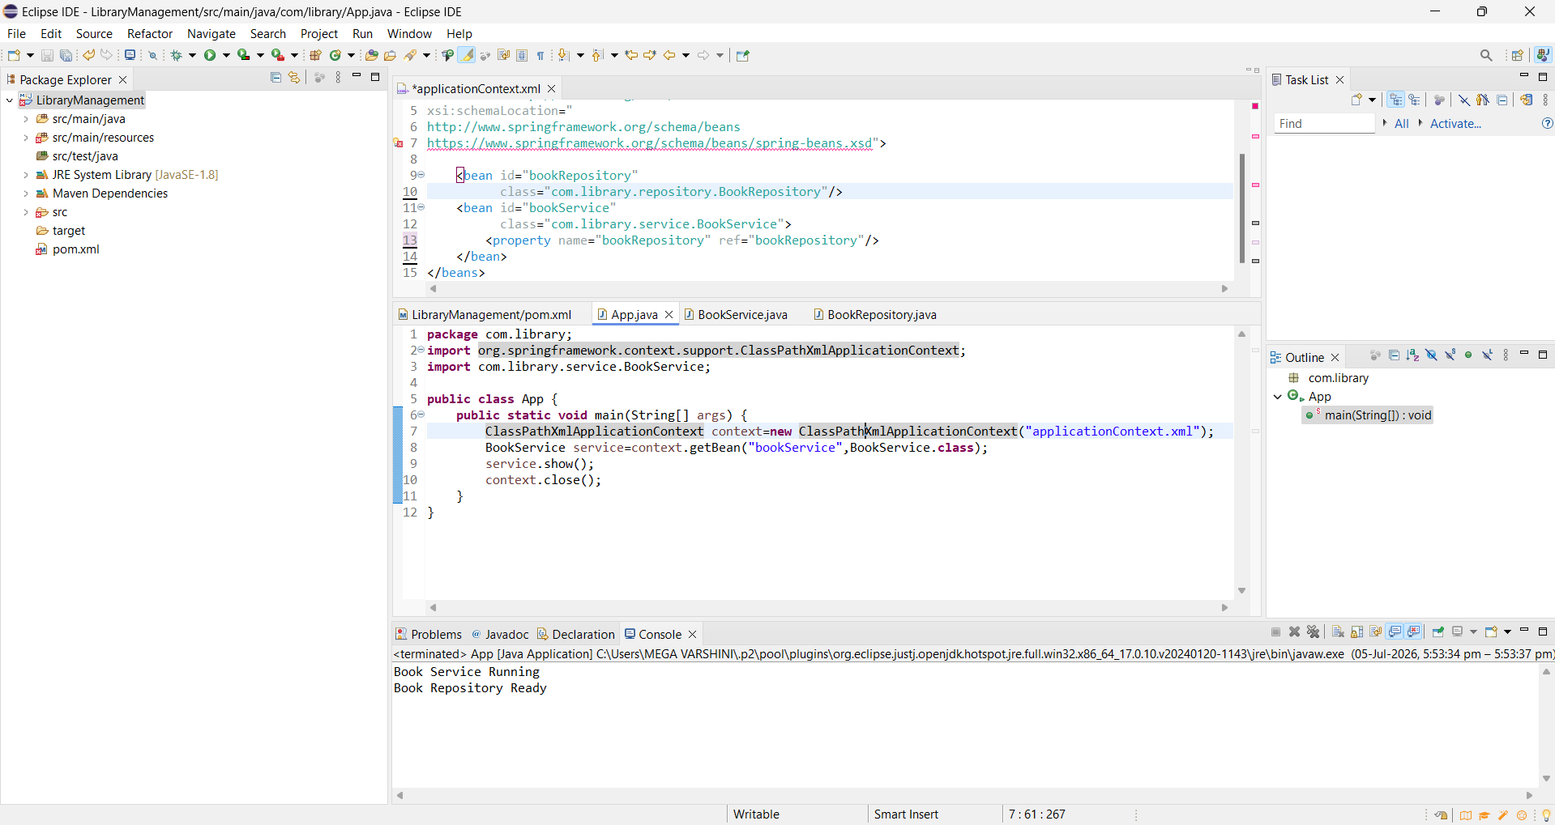
Exercise 4: Creating and Configuring a Maven Project
